SQL ASSIGNMENT -15

ROLL NO-84016

Q1 Assume there is a table called Multicust, with all of the same column definitions as Salespeople. Write a command that inserts all salespeople with more than one customer into this table.
Ans.

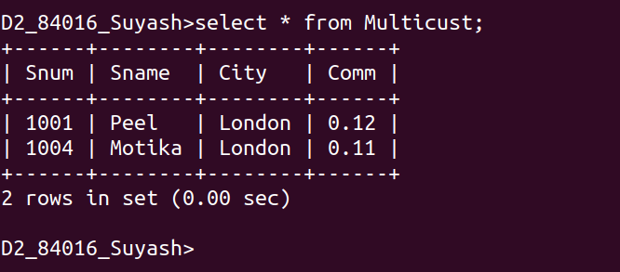

Q2.Write a command that deletes all customers with no current orders.
Ans.
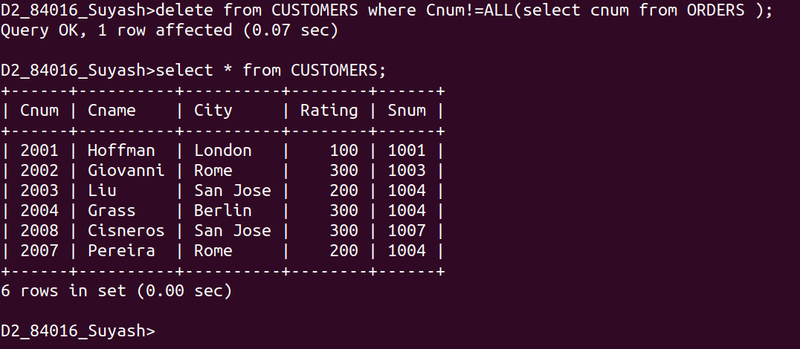

Q3.Write a command that increases by twenty percent the commissions of all salespeople with total orders above Rs. 3,000.
Ans.
